Lab: 3-4
BFS and DFS
Objective:
- To understand and implement the Breadth-First Search (BFS) algorithm.
- To learn how BFS explores the nodes of a graph level-by-level.
- To analyze the time and space complexities of BFS.
- To apply BFS for solving real-world problems, such as finding the shortest path in unweighted graphs.

Introduction to BFS:
Breadth-First Search (BFS) is a graph traversal algorithm that explores the graph level by level. It begins from a start node and explores all its neighbors first before moving to the next level of neighbors. BFS uses a queue data structure to ensure nodes are visited in the correct order.

Theory
Graph Terminology:
- Vertex (Node): A point in the graph where edges meet.
- Edge: A connection between two nodes in the graph.
- Adjacency List: A common way to represent graphs where each node stores a list of adjacent nodes.

Breadth-First Search (BFS):
- BFS Algorithm Steps:
  - Start from a designated node (source).
  - Mark the source node as visited.
  - Add the source node to the queue.
  - While the queue is not empty:
    - Remove a node from the queue.
    - Explore all its unvisited neighbors.
    - Mark these neighbors as visited and add them to the queue.
- Use Cases of BFS:
  - Shortest Path in Unweighted Graphs: BFS ensures that the first time a node is visited, it has been reached via the shortest path.
  - Level Order Traversal: BFS can be used to traverse a tree level by level.
  - Connected Components: BFS can identify all nodes in the same connected component of a graph.

Algorithm Implementation:
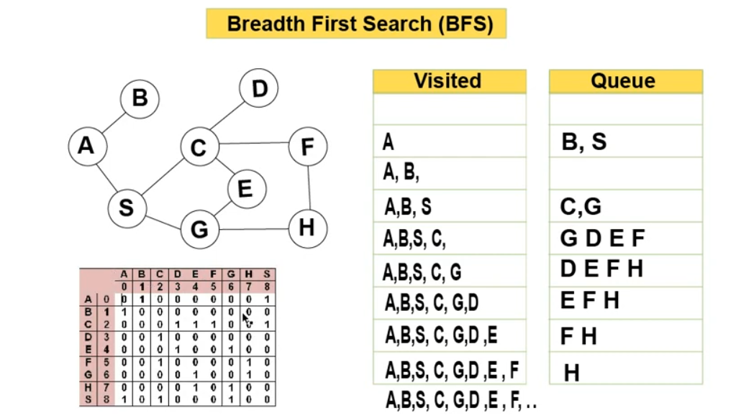

Source code:
#include <stdio.h>

int a[20][20], q[20]={0}, visited[20]={0}, n, i, j, f=0, r=-1;

void bfs(int v)
{
for (i=0; i<n; i++)
{
if (a[v][i] && visited[i]==0)
q[++r]=i;
}
if(f<=r)
{
visited[q[f]]=1;
bfs(q[f++]);
}
}

int main()
{
int v;
printf("\n Enter the number of vertices:");
scanf("%d", &n);
printf("\n Enter graph data in matrix form: ");

for(i=0;i<n;i++)
{
for(j=0;j<n;j++)
{
scanf("%d", &a[i][j]);
}
}

printf("Enter the starting vertex: ");
scanf("%d", &v);
bfs(v);
printf("\n The node which are reachable are:\n");

for(i=0;i<n;i++)
{
if(visited[i])
{
printf("%d\t", i);
}
else
{
printf("BFS is not reachable. Not all nodes are reachable");
break;
}
}
}

Output:
Enter the number of vertices:9
Enter graph data in matrix form:
0 1 0 0 0 0 0 0 1
1 0 0 0 0 0 0 0 0
0 0 0 1 1 1 0 0 1
0 0 1 0 0 0 0 0 0
0 0 0 1 0 0 1 0 0
0 0 1 0 0 0 0 1 0
0 0 0 0 1 0 0 1 0
0 0 0 0 1 0 1 0 0
1 0 1 0 0 0 1 0 0
Enter the starting vertex: 0

The node which are reachable are:
0 1 2 3 4 5 6 7 8

OR
#include <iostream>
using namespace std;

int main()
{
int n, e;
Cout<< "Enter number of node and edge: ";
cin >> n >> e;

int graph[100][100] = {0};
bool visited[100] = {false};

// Edge Input
for(int i = 0; i < e; i++)
{
int u, v;
cin >> u >> v;

graph[u][v] = 1;
graph[v][u] = 1;
}

int start;
cin >> start;

// Queue using Array
int q[100];
int front = 0, rear = -1;

visited[start] = true;
q[++rear] = start;

while(front <= rear)
{
int current = q[front++];

cout << current << " ";

for(int i = 0; i < n; i++)
{
if(graph[current][i] == 1 && !visited[i])
{
visited[i] = true;
q[++rear] = i;
}
}
}

return 0;
}

Output:
Enter number of node and edge: 5 5
0 1
0 2
1 3
1 4
2 4
Enter starting node: 0
BFS Traversal: 0 1 2 3 4

Time and Space Complexity:
- Time Complexity: O(V + E), where V is the number of vertices and E is the number of edges. This is because each vertex and edge is processed once.
- Space Complexity: O(V), due to the additional data structures (queue and visited set) used to store nodes.

Lab Exercises:
- Task: Implement the BFS algorithm for a given undirected graph using an adjacency list.

Real-Life Applications of BFS:
- Shortest Path Finding: BFS is widely used in unweighted graphs to find the shortest path from a source node to a destination.
- Social Network Analysis: BFS can be used to find all the people at a certain level of connection in social networks (e.g., "friends of friends").
- Web Crawlers: BFS is used in web crawlers to visit the nearest or directly connected pages first, systematically exploring a website.
- Puzzles and Games: Many puzzles (e.g., Rubik’s cube) or games (e.g., chess) require BFS to find the shortest solution.

Conclusion:
In this lab, we explored and implemented the Breadth-First Search (BFS) algorithm using Python. We analyzed its time and space complexities and worked through various exercises to deepen the understanding of BFS in practical scenarios. Through these activities, we learned how BFS explores graphs level by level and its usefulness in shortest-path problems.

DFS
Objective:
- To understand and implement the Depth-First Search (DFS) algorithm in Python.
- To learn how DFS explores the graph deeply by visiting child nodes before backtracking.
- To analyze the time and space complexities of DFS.
- To apply DFS for real-world problems such as detecting cycles, topological sorting, and solving mazes.

Introduction to DFS:
Depth-First Search (DFS) is a graph traversal algorithm that explores as far down a branch as possible before backtracking. It uses a stack data structure, either explicitly or through recursion, to keep track of the nodes to be explored next. DFS is fundamental in various graph-related problems such as detecting cycles, finding connected components, and pathfinding.

Theory
Graph Terminology:
- Vertex (Node): A point in the graph where edges meet.
- Edge: A connection between two nodes in the graph.
- Adjacency List: A common way to represent graphs where each node stores a list of adjacent nodes.

Depth-First Search (DFS):
- DFS Algorithm Steps:
  - Start from a designated node (source).
  - Mark the source node as visited.
  - Recursively visit each unvisited neighbor, diving deeper into each branch before backtracking.
  - If all nodes connected to the current node have been visited, backtrack to the previous node.
  - Continue this process until all reachable nodes are visited.

- DFS Use Cases:
  - Pathfinding in Mazes: DFS explores all possible paths by going as deep as possible along each path before backtracking.
  - Cycle Detection: DFS can detect cycles in a graph by revisiting an already visited node in the same path.
  - Topological Sorting: DFS can be used to sort nodes in a Directed Acyclic Graph (DAG) based on dependencies.
  - Connected Components: DFS can be used to explore all nodes in a connected component of a graph.

Algorithm Implementation

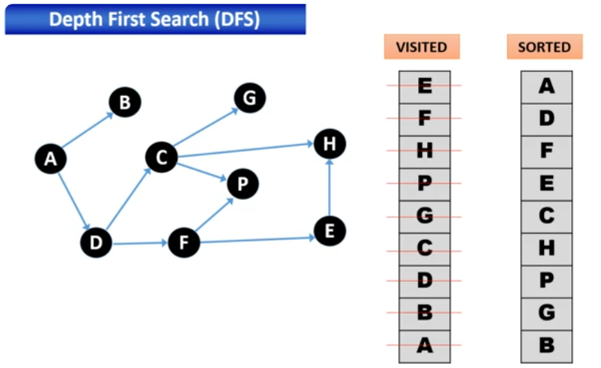

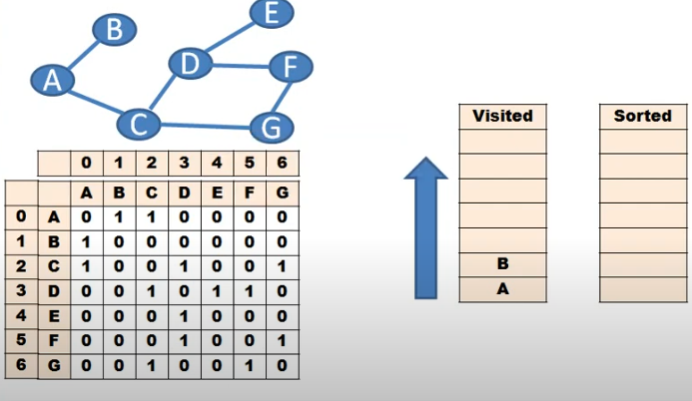

Source code: (DFS Traversal Visited node)
#include <stdio.h>
void DFS(int);
int G[10][10], visited[10]={10}, n;

int main()
{
int i,j;
printf("Enter the number of Vertices: ");
scanf("%d", &n);
printf("\nEnter the adjacency matrix of the graph: ");

for(i=0;i<n;i++)
{
for(j=0;j<n;j++)
{
scanf("%d", &G[i][j]);
}
}
DFS(0);
}

void DFS(int i)
{
int j;
printf("\n%d", i);
visited[i]=1;
for(j=0;j<n;j++)
{
if(visited[j]==0 && G[i][j]==1)
DFS(j);
}
}

Input:
0 1 1 0 0 0 0
1 0 0 0 0 0 0
1 0 0 1 0 0 1
0 0 1 0 1 1 0
0 0 0 1 0 0 0
0 0 0 1 0 0 1
0 0 1 0 0 1 0

Time and Space Complexity:
- Time Complexity: O(V + E), where V is the number of vertices and E is the number of edges. This is because each vertex and edge is processed once.
- Space Complexity: O(V) due to the recursion stack or the explicit stack that stores vertices during traversal.

Lab Exercises:
Exercise 1: Basic DFS Implementation
- Task: Implement the DFS algorithm for a given undirected graph using an adjacency list.

Post-Lab Analysis:
- What is the primary difference between DFS and BFS in terms of their traversal methods?
- In which situations would DFS be more useful than BFS?
- Why is DFS more suitable for solving problems like detecting cycles or performing topological sorting?
- How does the use of recursion or an explicit stack in DFS affect its space complexity?
- What are some real-world applications of DFS beyond graph traversal?

Real-Life Applications of DFS:
- Cycle Detection: DFS can be used to detect cycles in both directed and undirected graphs, making it useful in dependency management systems.
- Topological Sorting: In scenarios like task scheduling, where certain tasks need to be done before others, DFS can be used for topological sorting.
- Maze and Puzzle Solving: DFS explores all possible paths deeply before backtracking, making it suitable for finding solutions to mazes and puzzles.
- Pathfinding Algorithms: DFS can be used for pathfinding in graphs where all possible paths need to be explored deeply, such as AI in games.

Conclusion:
In this lab, we explored and implemented the Depth-First Search (DFS) algorithm using Python. We discussed the theoretical background of DFS and analyzed its time and space complexity. Through various exercises, we applied DFS to real-world problems like cycle detection, topological sorting, and finding connected components. The lab helped us understand how DFS differs from BFS and in which scenarios DFS is the preferred traversal method.

